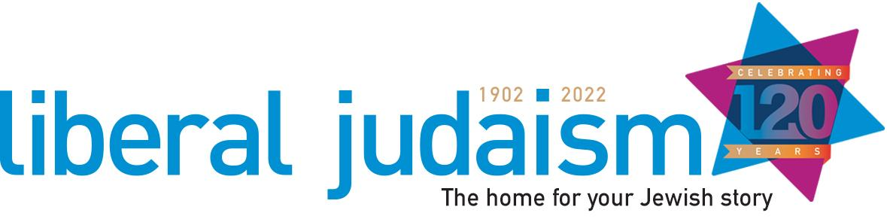

**Membership Manager Job Description**

**Function of the Post:** To support the heart of Liberal Judaism, our communities! Nurturing the learning and training within Liberal Jewish communities, supporting the growth of collaborative communities and building new and constructive relationships and partnerships.

**Location:** Hybrid; home and office base in central London. Some work at events in the UK.

**Hours:** Role is 85% (4 days a week) but the split of hours is flexible in agreement with the CEO.

**Salary:** £38-£49k full time equivalent (Role is 85%, so £32.3- 34k).

**Reporting to:** CEO of Liberal Judaism

**Key Responsibilities**

* To develop and maintain proactive and positive collegiate relationships with Liberal Judaism’s member communities, offering support and developing resources and responses to communal needs.
* To manage special projects, developed to support Liberal Judaism communities, including working as an ambassador and developing new projects as required.
* To manage rabbinic placements and agreements in line with community needs and to develop good working relationships with rabbis and student rabbis and Leo Baeck College.
* To work in partnership with a range of organisations to meet the needs of Liberal Judaism’s communities.
* To support the engagement of Liberal Judaism communities in fundraising and annual events.
* To manage membership data for Liberal Judaism in accordance with GDPR.

**Relationships between communities and Liberal Judaism**

* Sending and collating the results of the annual community returns, including developing new resources where needed and ensuring that requested support is delivered, either directly or through colleagues.
* Developing strong relationships with key volunteers and staff within communities, not limited to Chairs, Treasurers and administrators, proactively offering support and assistance and responding to queries.
* Delivering induction for new members of Council; maintaining a register of members and voters and ensuring processes are followed correctly relating to membership, in conjunction with other staff.
* Organising small action groups to tackle issues of concern, using staff, volunteers and others to deliver new solutions and processes.
* Attending meetings dealing with community issues and LJ as required, for example the Burial Officers meeting.
* Supporting the small communities network, offering learning and support opportunities, as well as working with the leadership of small communities to build strategies for growth and development.

**Projects**

* Managing the Ba’alei Tefillah programme, from recruitment and support of candidates to all aspects of the delivery of the programme. Work as an ambassador for the programme with communities and rabbis.
* Managing the Honeycomb project, including the administration of courses and groups. Work as an ambassador for the programme with communities and rabbis.
* Sitting on the Honeycomb project steering group.
* Working in partnership to develop new projects and opportunities as needs are identified.
* Managing the weekly community briefings.
* Implementing and managing a new CRM system.

**Rabbinic Placements and Student Rabbis**

* Working closely with the Chairs of communities to understand their rabbinic needs and fulfilling these needs through the provision of rabbinic support. Ensuring the smooth administration of this work.
* Organising the allocation of rabbis to pulpits for the High Holy Days and administering this process.
* Developing relationships with current student rabbis.

**Partnership Working**

* Nurturing relationships with peers in organisations within and outside the Jewish community for the benefit of Liberal Judaism’s member communities.
* Seeing opportunities to create partnerships within Liberal Judaism and Liberal Jewish communities and further afield.

**Other**

* Holding accountability for the administration of the work required to support Liberal Judaism’s communities and members, including finance systems as a departmental lead.
* Working on annual events, where required, to promote and encourage participation and the delivery of programmes that meet member needs.
* Engaging in fundraising events and working to promote the benefits of fundraising with Liberal Judaism communities, encouraging and supporting communities to participate.

**Person Specification**

**Essential**

* Knowledge and understanding of the UK Liberal Jewish community.
* Experience of developing services to meet the needs of members.
* Experience of community support and development work.
* Experience of working collaboratively to solve problems and tackle issues of concern.
* Experience of data management/CRM system.
* Ability to manage conflicting demands and prioritise effectively.
* Effective communicator with the ability to build positive working partnerships.

**If you would like to discuss this role further before application, please do not hesitate to contact Rabbi Charley Baginsky by email (**[**c.baginsky@liberaljudaism.org**](mailto:c.baginsky@liberaljudaism.org)**)**

**To apply, please email a copy of your CV and a covering letter, outlining your relevant experience and interest in this role to** [**t.garfield@liberaljudaism.org**](mailto:t.garfield@liberaljudaism.org) **by   
5pm on Monday 4th April.**